**Module 6: MIS581 Final Project Draft**

Madison Ritchie

MIS581-1– Capstone: Business Intelligence and Data Analytics

Dr. Bateh

Jul 31, 2023

**Abstract**

To be completed week seven.

**Introduction**

**Background**

The cosmetics industry continues to expand globally. In 2019 the global cosmetic market was valued at $380.2 billion and is estimated to grow to $463.5 billion by 2027 (Nitesh et al., 2021). The cosmetics industry target audience spans across various demographics and product types. Products target both aesthetic concerns and personal care. As stated by Li et al., “no matter what age, location or socioeconomic background, we are all exposed to the widespread cosmetics industry” (pp. 3-15). The cosmetics industry is constantly evolving to meet the changing demands of consumers. Direction of the beauty industry rapidly changes with new innovations, market trends, and technological advancements occurring daily (Fisher et al., 2019). This means that the companies can benefit from conducting research projects with the latest competitor data to stay on top of the market.

One area of focus within the cosmetic industry is specialty/prestige beauty brands which are sold online and on the store shelves of brands such as Sephora, Ulta, etc. Specialty beauty is targeted towards a specific demographic which can include factors such as age, skin type, or price range. This market of cosmetics differs from other store cosmetics in that the customer demographic is more focused and consumers search for a specific solution.

With the increased availability of data and consumer awareness one specific trend in specialty beauty is increased consumer awareness of product ingredients. In cosmetics, ingredients are the powering mechanism behind the product producing the desired effect. Today product ingredients are available both on physical labels and through online store listings. Websites such as INCO Decoder and Beautypedia Skincare Ingredient Checker assist consumers in research by allowing them to research products ingredient by ingredient simply by uploading a picture of a product label. Consumers are more likely to be informed which ingredients are contained in their products and with this information in mind make more informed purchasing decisions. Ingredient desirability can be based on many sources of information such as news, word of mouth, product reviews, advertising, and social media. Furthermore, increased data availability means consumers are more likely to make purchasing decisions based on reviews and product ratings available on brand websites. Beauty industry brands can take advantage of this data availability by researching the ingredient formulas and ratings of both their own products and competitor products.

**Problem/Purpose**

The project objectives are to determine whether ingredients in specialty skincare products have a correlation with favorable product reviews. This information is useful as identifying trends and effectiveness can be used to formulate future products. Analysis and findings in the beauty industry is constantly changing as new products are released and others are discontinued every day. Increasing sales in cosmetic brands is all about meeting the needs of the consumer by producing effective products they want to continue using and repurchasing.

**Objectives**

**Aims/Objectives/Goals**

Through the steps of data analysis, the project will dive into the relationship between product ingredients and rating. Product rating is essential to track as it determines how consumers view the product. A high product rating means the product is liked by consumers so that they are more likely to repurchase or recommend to other consumers. The aim of the project is to determine the relationship between the data fields of ingredients and rating.

The primary aim of the project is to learn more about how product ingredients correlate with resulting product rating. This information allows for the company to understand how competitor products are formulated and currently performing in the consumer space. It also provides insight into current skincare formulation trends. This information allows for P&G to adjust their own products so that they remain competitive in the constantly changing market.

**Benefits to Organization**

The overall goal of P&G is to produce the highest quality and best-selling cosmetic products. In the specialty cosmetic market, consumers have access to more data now than ever at their fingertips. Consumers make more informed decisions based on factors such as past ratings and self-research. This information is also at the disposal of cosmetic brands. As stated by Park et al., “In keeping up with the leading business trends, cosmetics firms also leverage big data and build their brand partnerships across industries and apply the Internet-of-Things (IoT) and Artificial Intelligence (AI) for their product and process development” (2022). Leveraging data from both P&G’s own products and competitors allows them to research data relationships. From this research, P&G can determine changes to make to their own products. On the development side, the company can alter the formulations of existing products or develop new entirely new products. On the marketing side, the company can discover how to market claims for products and determine targeted demographics for products. P&G skincare brands in which this research can be applied to include Olay, SK-II, Tula Skincare, First Aid Beauty, and Farmacy Beauty. All these findings allow P&G to create products that keep up with the industry latest and are of the highest quality.

**Overview of Study**

The objective of the study is to explore the relationship between product ingredients, rating, and targeted skin concern. A dataset was obtained from Kaggle, an online data science and machine learning community that allows for users to share open-source datasets for exploration and analysis (see Figure 1 to view initial dataset as obtained from Kaggle). The dataset is composed of a recent web scraping of the skincare product listings on the Sephora website. Sephora is one of the largest specialty beauty retail store chains. According to Maamoun (2022), “Beauty-specialist stores like Ulta and Sephora make up the second-fastest-growing U.S. retail category in the past five years, after off-price retailers” (pp. 94-102). Sephora makes an ideal selection of a dataset for this research project as it carries a diverse range of skincare cosmetics including the most recent brand launches. Recent data is necessary in the specialty beauty industry as new products are constantly cycled in and others discontinued. Products include a variety of skincare products including moisturizers, cleansers, eye creams, treatments, face masks, and sunscreens.

The data analysis portion of the project will consist of cleaning/transforming the original dataset, performing analysis, and drawing conclusions. Data cleansing and analysis will be performed through python programming language. Analysis will consist of linear regression test and k-clustering means test. For further details on data analysis see the Research Design section. Insights found through analysis can lead to a better understanding of the effectiveness of ingredients in skincare products and the marketing trends utilized by other brands. Additionally, another aim is to use clustering to identify competitive products for better product comparison against each other. Conducting this research project is important to the business as it can be used to guide company strategy in deciding product formulations and branding.

**Research Questions & Hypotheses**

**Research Question**

The general question posed in this research paper is what is the relationship between various skincare data fields? Data fields include variables such as product name, brand, price, consumer rating, ingredients list, and target skin type. More specific questions posed from this data set include what is the relationship between product ingredients and variables such as rating? Additionally, can products be clustered into groups of competitive products based on similarities?

**Hypotheses**

A hypothesis differs from a research question in that it is a more specific predictive statement. The first research question is what is the relationship between product ingredients and the variable rating? The null hypothesis (Ho) is there is no correlation between product ingredients and the variable rating. The alternative hypothesis (Ha) is there is a correlation between product ingredients and the variable rating.

The second research question is can products be clustered into groups of competitive products based on similarities? The null hypothesis (Ho) is the dataset is uniformly distributed and competitive products cannot be grouped together. The alternative (Ha) hypothesis is clusters exist and clusters can group together competitive products. Both of the hypotheses developed for this research project will be tested through machine learning algorithms utilizing the python programming language.

**Literature Review**

**Online Retail and Purchase Intention**

Specialty beauty is largely driven by trends and formulating/marketing products to specific customer demographics. Beauty retailers, such as Sephora are seeing a shift in consumer behavior towards increased online shopping. In a study analyzing online shopping trends since the start of the pandemic, retailers saw a large spike in e-commerce brought on by the Covid-19 lockdown and continue to see a potentially permanent consumer behavior shift (Alfonso, 2021). Within e-commerce one area of interest for research is purchase intention, or the likelihood that a customer will purchase a product. A variety of factors influence a consumer’s decision on whether they will purchase a product.

Various studies have been performed by human behaviorists with common factors found between them including attitude, subjective norms (belief that people will approve of the behavior), and perceived behavioral control (confidence consumer has to perform a behavior) (Peña-García, 2020). Recent studies suggest that these all play a part in consumer purchase intention along with many other values including age, gender, cultural norms, etc. Additionally, on online platforms consumer are exposed to ratings and reviews data which can drive their decision making. Retails can grow their understanding of consumer behavior so that they can adjust their products to meet their needs.

**Competitive Analysis**

Competitive analysis involves researching competitors to gain an understanding of how the company’s product is performing. As stated by Milusheva (2020), “the purpose of business organization's competitiveness analysis and evaluation is to determine organization's condition, its position with respect to its sectoral competitors” (pp. 401-409). Today consumers have a variety of brand options for almost every product they purchase. Consumers make purchasing decisions on a variety of reasons including in-store accessibility, brand reputation, and product quality. Competitive analysis gives the company to see where the brand is performing well and where there is room for improvement. One area of interest within competitive analysis is the analysis of social media data through both supervised and unsupervised methods (Yang et al., 2022). Social media is a wealth of information for companies. Consumers leave textual reviews on products which can be analyzed to find strengths and weaknesses. While ratings on shopping websites can be useful consumers may choose to share opinions differently through social media sites. The social media perspective can be used as a supplement to other rating data.

**Research Design**

**Methodology**

A dataset was compiled of a recent web scraping of the skincare product listings on the Sephora website. The dataset consists of 1473 products both from P&G internal brands (Farmacy and First Aid Beauty) and a variety of competitor brands sold at Sephora.The dataset includes eleven columns, one for each product. The columns include Label, Brand, Name, Price, Rank, Ingredients, and a column each for the target skin types Combination, Dry, Normal, Oily, and Sensitive.

The Label variable is a string that contains one of the following categories: moisturizer, eye cream, cleanser, treatment, face mask, or sunscreen. Brand variable is a string with the product brand. Name is a string variable with the specific product name. Price is an integer variable that gives the price of the product to the nearest dollar in US dollars. Rank is an integer variable with one decimal place that provides the overall star rating of the product as ranked by reviews submitted by customers to the Sephora website. The ingredient column contains a list of ingredients in the comma-delimited form. This column will require transformations to put the data in an analyzable form. Each of the skin types are in the binary from with 1 meaning true and 0 meaning false.

For additional metadata details in tabular format a data dictionary was created (see Appendix). Information included in the data dictionary includes variable, type, description, and source. As the dataset was obtained from a prefiltered source some fields found in traditional data dictionaries are not available.

**Methods**

Based on the type of data available, the first hypothesis will be tested though a supervised liner regression test. A linear regression test, as described by Maulaud & Abdulazeez (2020), “is a mathematical test used for evaluating and quantifying the relationship between the considered variables” (pp. 140-147). In particular a liner regression tests will be performed with product ingredient as the independent variable and rating as dependent variables. Data was prepped for the linear regression by delimiting the ingredients row and creating a separate row for each ingredient per product (Figure 2). Determining whether a relationship exists between these variables has the potential to guide future decisions on product formulations.

The second set of hypotheses around competitive product clustering will be tested through an unsupervised k-clustering test. A k-clustering test works by finding patterns in the data set and grouping those with similarities together and those with differences in different clusters (Sinaga & Yang, 2020). The potential to group products that are similar into competitive clusters helps the company to compare competitor products against their own similar products. Competitive products serve as a learning opportunity to which products are performing better with consumers so adjustments can be made. Unsupervised learning algorithms, such as the k-clustering test, are an essential tool in marketing as they provide valuable insight into patterns between customers, competitors, and industries (Mitić, 2019). As the specialty skincare industry is largely trend driven, the ability to identify patterns is beneficial in discovering trends as they emerge. Knowledge on trends can be utilized to better formulate and market products to consumers. For the k-clustering test individual products will be grouped and the input variables will include the numerical values price and rank. Target sin type will also be included though data is in binary format. The variable product type (label) was converted to the binary format through adding dummy variables. The final dataset utilized for model is displayed in Figure 6. Additionally, data was scaled beforehand due to the mixed numerical nature of the data (Figure 7). This step ensures that each variable is evaluated with equal weight.

**Limitations**

Limitations exist on the accuracy the models can be used to draw conclusions. The liner regression and k-clustering model will be tested on a 95% confidence interval for accuracy. Despite these measures, both models are only as accurate as the dataset the algorithm was trained on. The Sephora dataset was pulled in 2020, which means the product listings will have some differences from the present day. One major concern associated with the dataset is the large portion of categorical variables in the dataset. While the linear regression and k-means clustering models are possible with categorical inputs, the models can be skewed. Additionally, models such as linear regression and k-clustering are sensitive to outliers in the dataset.

**Ethical Considerations**

The dataset is composed of a recent web scraping of the skincare product listings on the Sephora website. Web scraping refers to the extraction of data from a website and is becoming more common in research with increased digitalization. As of today, there are no set of fundamental legal theories or laws specifically addressing the legality of web scraping. Instead, people who perform web scraping are limited by related laws such as legal use of data, breach of contract, copyright infringement, and trespass to chattels (property excluding real estate) (Krotov, 2020). Additionally, common sense rules to follow include not exhausting the scraped website, respecting people’s personal privacy but not collecting identifiable information, and being transparent with the use of data. The dataset for this research project was obtained from Kaggle, an online open-source data science and machine learning community, which meant the data was already compiled into one source. Before performing research, the dataset was checked for any sensitive fields such as personal identifiable information and was determined not to contain any.

**Findings**

**Linear Regression**

All data preparation and tests were performed through python coding. For the purpose of visualization, a local web app was created using the open-source app framework known as Streamlit. A linear regression test (Ordinary-Least Squares) was performed with product ingredient as the independent variable and rating as the dependent variables utilizing the Statsmodel package (Figure 3). The number of observations was 1472 while the while the degree of freedom was 697. The large difference between these values occurred as the data set contained a large number of unique ingredients. The R-squared value was determined to be 0.567, the F-statistic was 1.179, and the corresponding p-value was 0.0131. The p-value represents the probability of observing the coefficient value. A p-value lower than the significance level (0.05) represents the model fitting the data while a high p-value is not of good of a fit. The p-value of 0.0131 is lower than significance level which means the null hypothesis (Ho) is there is no correlation between product ingredients and variable rating is rejected.

Data for the linear regression was visualized through both a traditional scatterplot and a scatterplot including mean bars with ingredients as the x-axis and ranking as the y-axis (Figures 4 and 5). Since the x-axis is categorical in nature the scatterplot does not exhibit the “common” linear regression line shape. Also evident from the graph, the high number of ingredient categories means many ingredients only contain one ranking value. Through visual inspection it is also evident that ranking is skewed in the 3-5 range. There are also several datapoints with a 0 ranking which may influence that ingredient group. Although the results were significant from the linear regression test, these results need to be verified with further research. The dataset contained a large amount of categorical data with each only having a few data points. Additionally, naming for ingredients was not uniform between all products which may have resulted in separate categories.

**K-Mean Clustering**

The K-means clustering test was performed through python code and the Sklearn package. The ideal number of clusters was found for the model by following the Elbow Method and determined to be 20. Clusters were added to the original data frame (Figure 8). After running, the average silhouette was calculated to be 0.54768 (Figure 9). A silhouette score varies in width between -1 and 1 with a negative value relating to greater dissimilarity. The greater a positive value the more likely the higher likelihood the element is clustered in the correct group (Shutaywi & Kachouie, 2021). While researchers are not in unanimous agreement, in general a silhouette index below 0.4 indicates weak clusters. The silhouette index of 0.54768 indicates weak clusters. Data was visualized through a scatterplot with cluster centroids marked (Figure 10). It is evident from visual analysis that data points are very spread out across the graph. While centroids group together similar data points, a large portion of datapoints are excluded in the classification.

The original null hypothesis (Ho) is the dataset is uniformly distributed and competitive products cannot be grouped together. However, when researching the limitations of the k-cluster, it was determined there is no accepted cut off to reject the null hypothesis. As stated by Fuentes & Casella (2009) “assessing whether clusters are significant is a question that has been asked by a number of experimenters” and “actual evaluation of the posterior probabilities is computationally intensive” (p. 115). K-means clustering is an unsupervised learning method which is better suited to exploring data to formulate hypotheses than to test a hypothesis. Due to the inability to verify significance, the null hypothesis is neither rejected nor failed to reject for this study. Alternative recommendations for testing will be further discussed in the recommendations section.

**Conclusion**

The specialty beauty industry is a continually expanding product market largely driven by a competitive market, new research, and trends. Consumers have a wide variety of products to select from. Companies, such as the consumer goods supplier P&G, can increase their success in the industry by conducting research into the ever-changing market. Two areas of interest in research include purchase intention and competitive analysis. This research project utilizes the product listing data web scraped from the specialty beauty retailer Sephora. Two research questions were proposed, and a hypothesis used to test each separately. What is the relationship between product ingredients and variables such as rating? Can products be clustered into groups of competitive products based on similarities? Ingredient and rating relation was tested through a linear regression test and the null hypothesis was failed to reject. This relationship should be further explored for verification in other studies. Potential clustering was tested through k-means clustering but the null hypothesis testing was inconclusive. Further hypothesis testing can be performed in this topic. The findings from this research serve as a further guiding point for research into market research and formulation decisions in the specialty beauty industry.

**Recommendations**

This research introduced a linear regression test for investigating the relationship between product ingredients and product ranking. The Sephora dataset was web scraped which means it was limited in size to one retailer and only as accurate as the data fields on the website. Another source may be available containing multiple retailers and standardized names for ingredients. Increasing the sample size of the test and reducing the number of null and inaccurate values would increase the accuracy of the test. Additionally, I noticed skews in the product review data with the majority of product having a high rating (3-5) or an extremely low rating (0). There was a lack of reviews in the middle range. A further investigation can be conducted into whether Sephora screens reviews before including on the website. Additionally, it is possible a bias exists in reviews since consumers are more likely to submit a review when they have an extreme opinion on a product (whether it be positive or negative). Data can be verified through checking alternative sources such as other retailers. The k-means clustering test was inconclusive in testing the original research hypothesis. As far as k-means tests, the results can be improved by increasing the sample size and verifying the validity of review data.

**Figures**

**Figure 1**

*Original Kaggle Dataset*

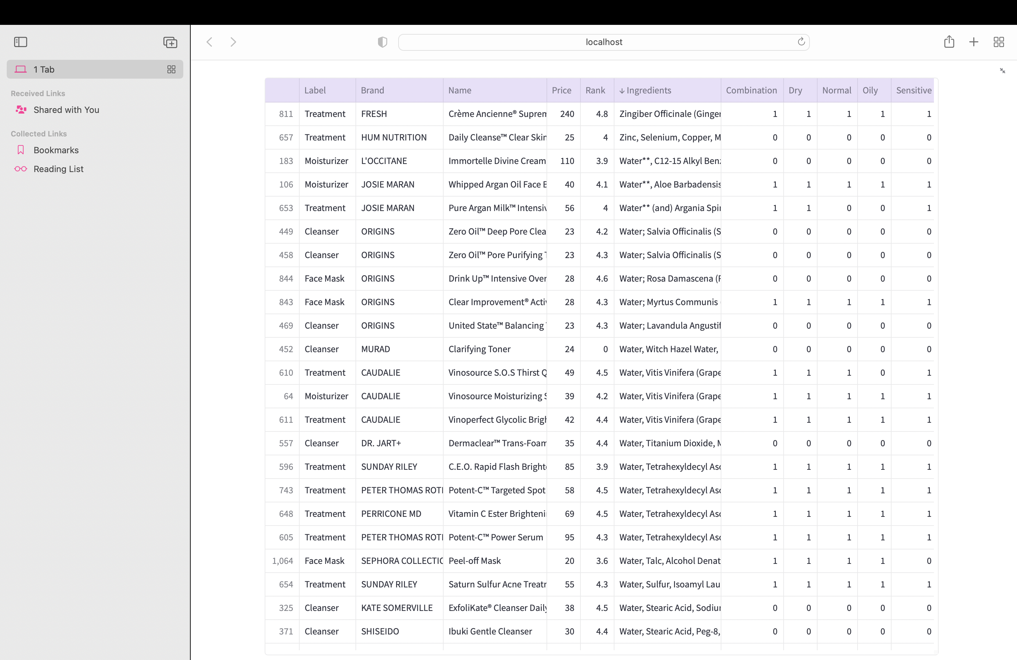

*Note.* Screenshot displaying unedited dataset as obtained from Kaggle website.

**Figure 2**

*Linear Regression Dataset*

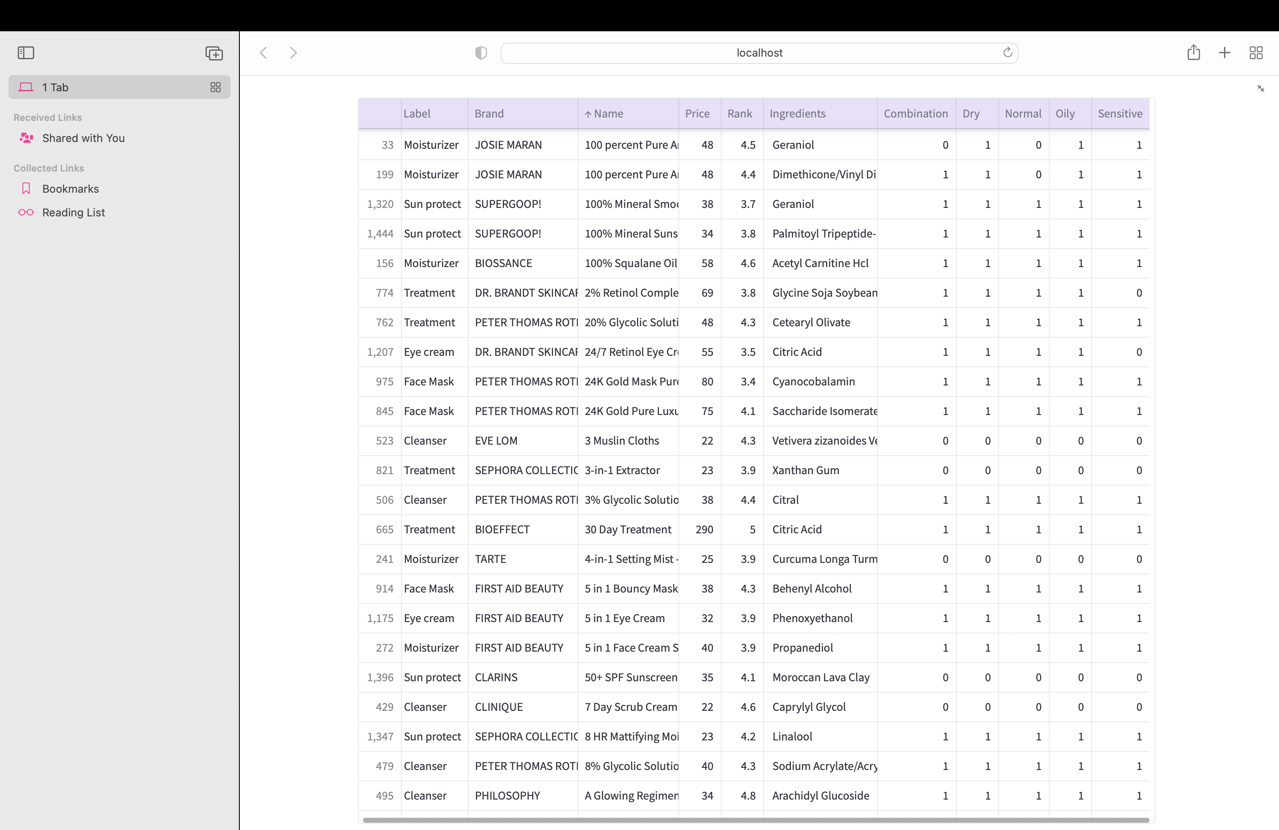

*Note.* Screenshot displaying screenshot of dataset prepared for linear regression test.

**Figure 3**

*Linear Regression Results*

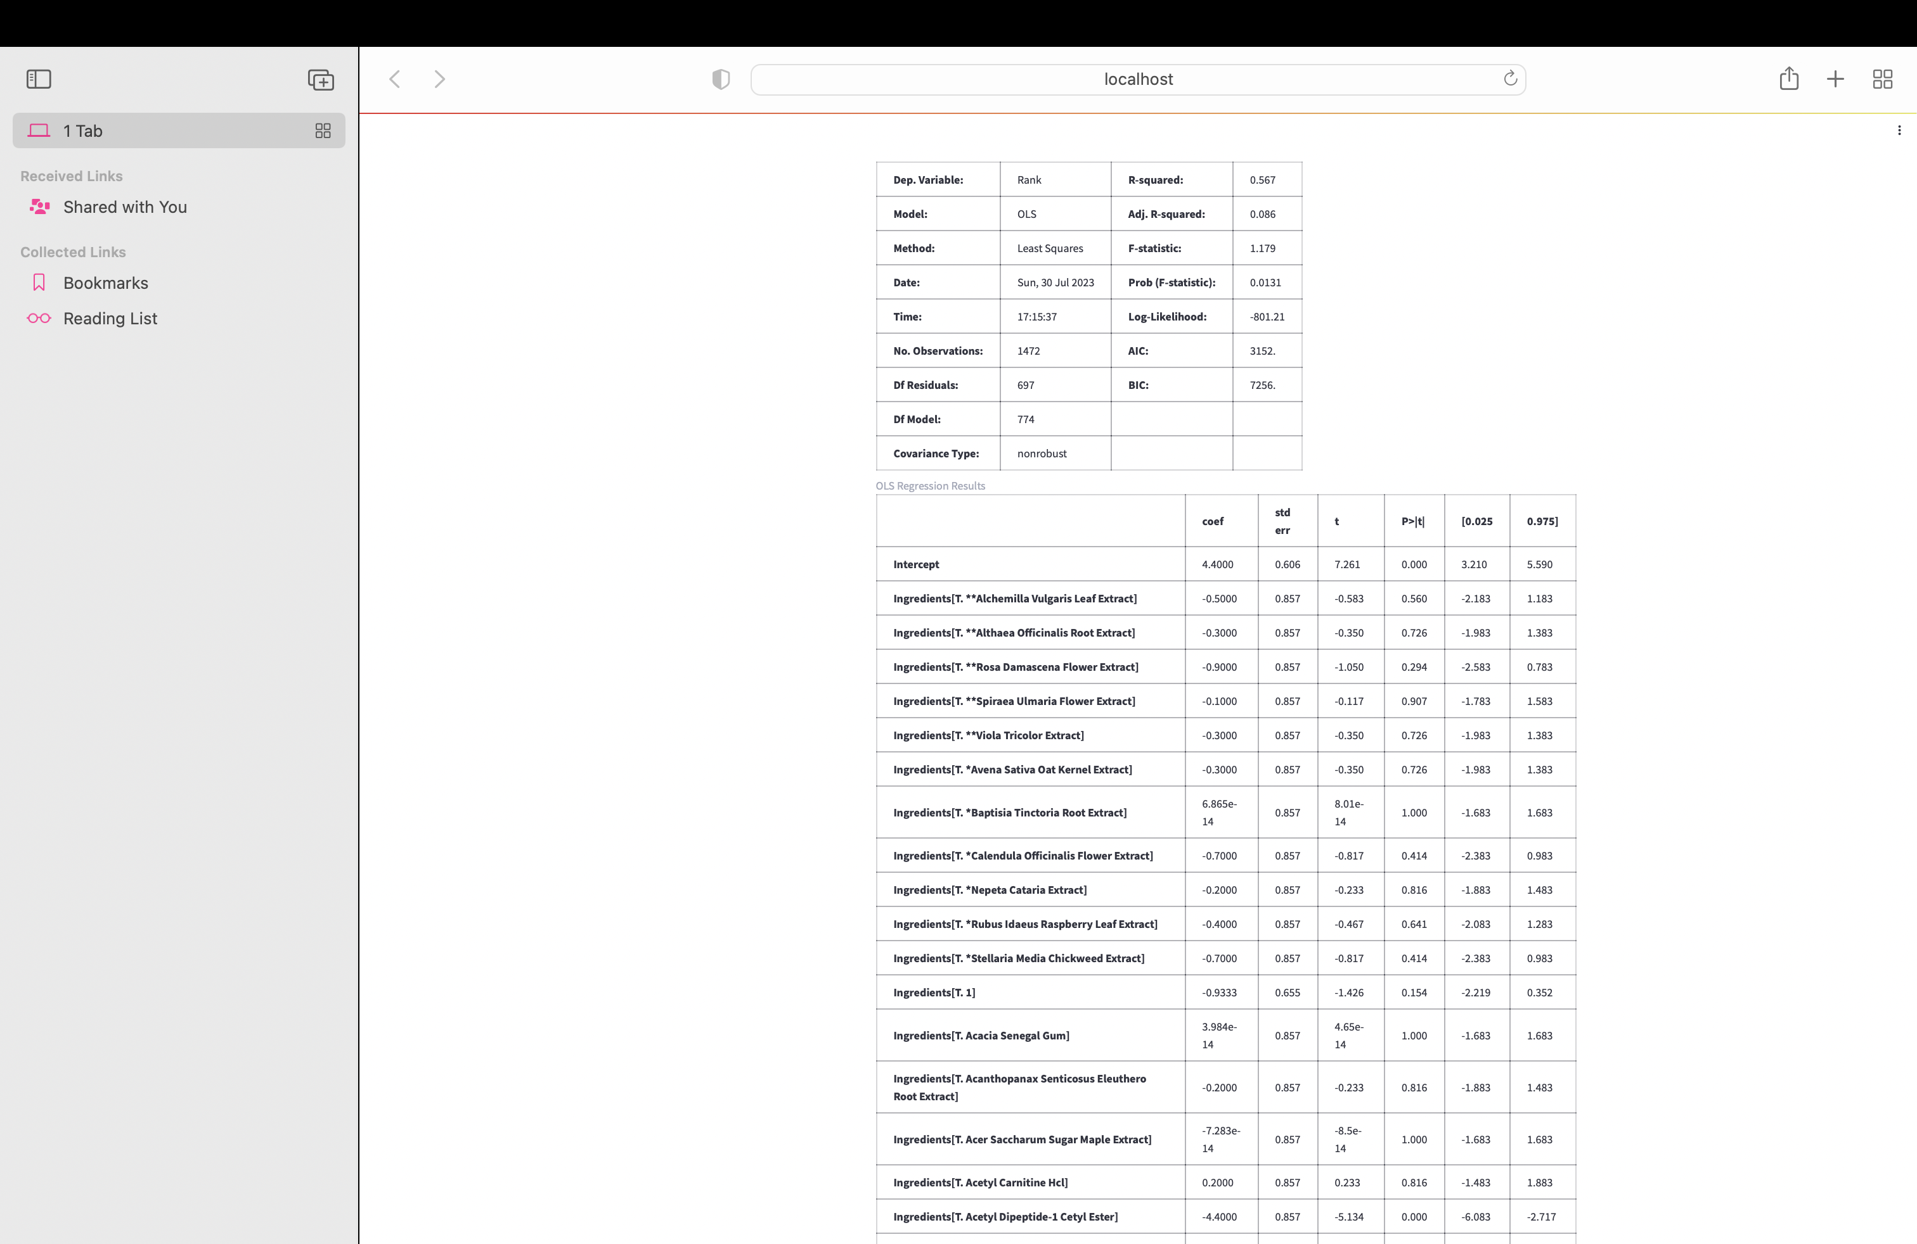

*Note.* Screenshot displaying results for linear regression test.

**Figure 4**

*Ingredient vs. Ranking Scatterplot*

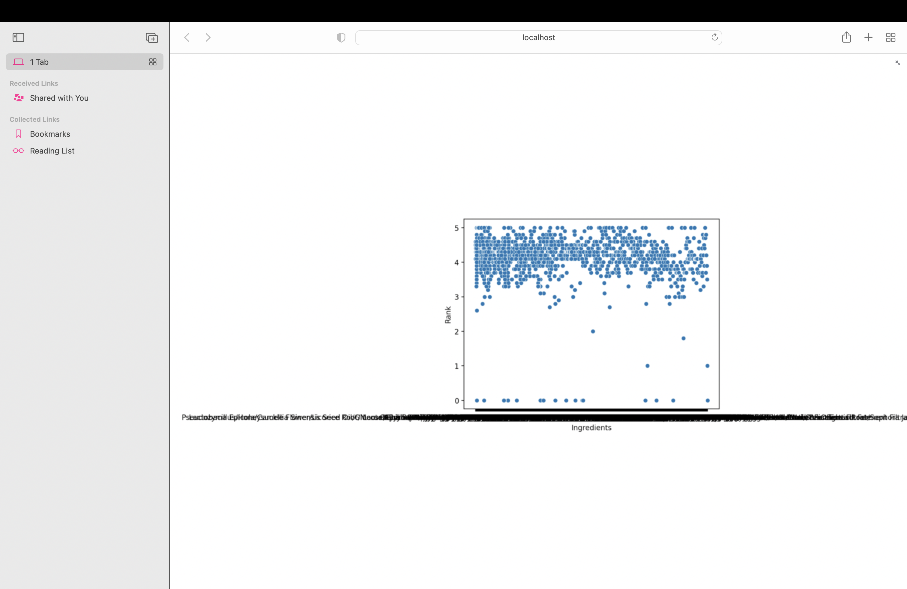

*Note.* Scatterplot displaying Ingredient on x-axis and Rank on y-axis.

**Figure 5**

*Ingredient vs. Ranking Scatterplot with Mean Bar*

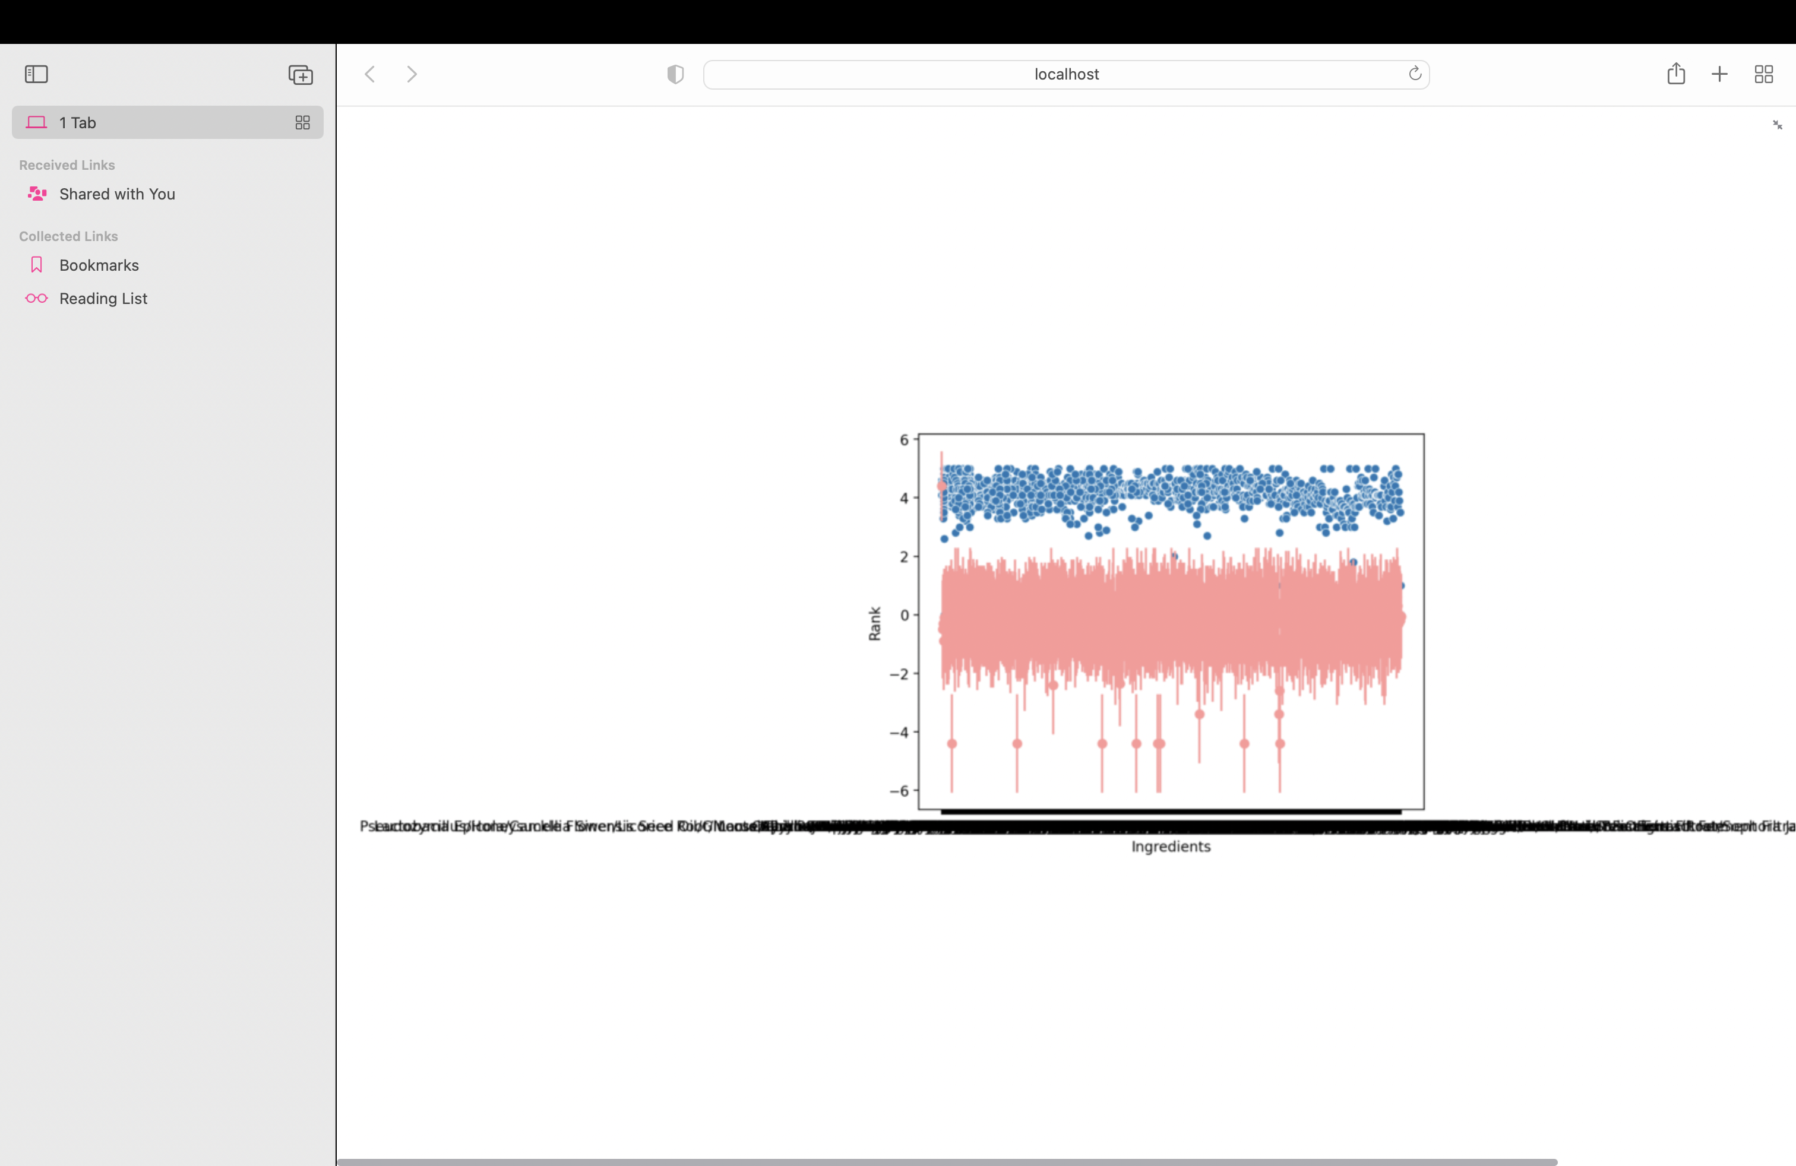

*Note.* Scatterplot displaying Ingredient on x-axis and Rank on y-axis with mean bar.

**Figure 6**

*K-Means Dataset*

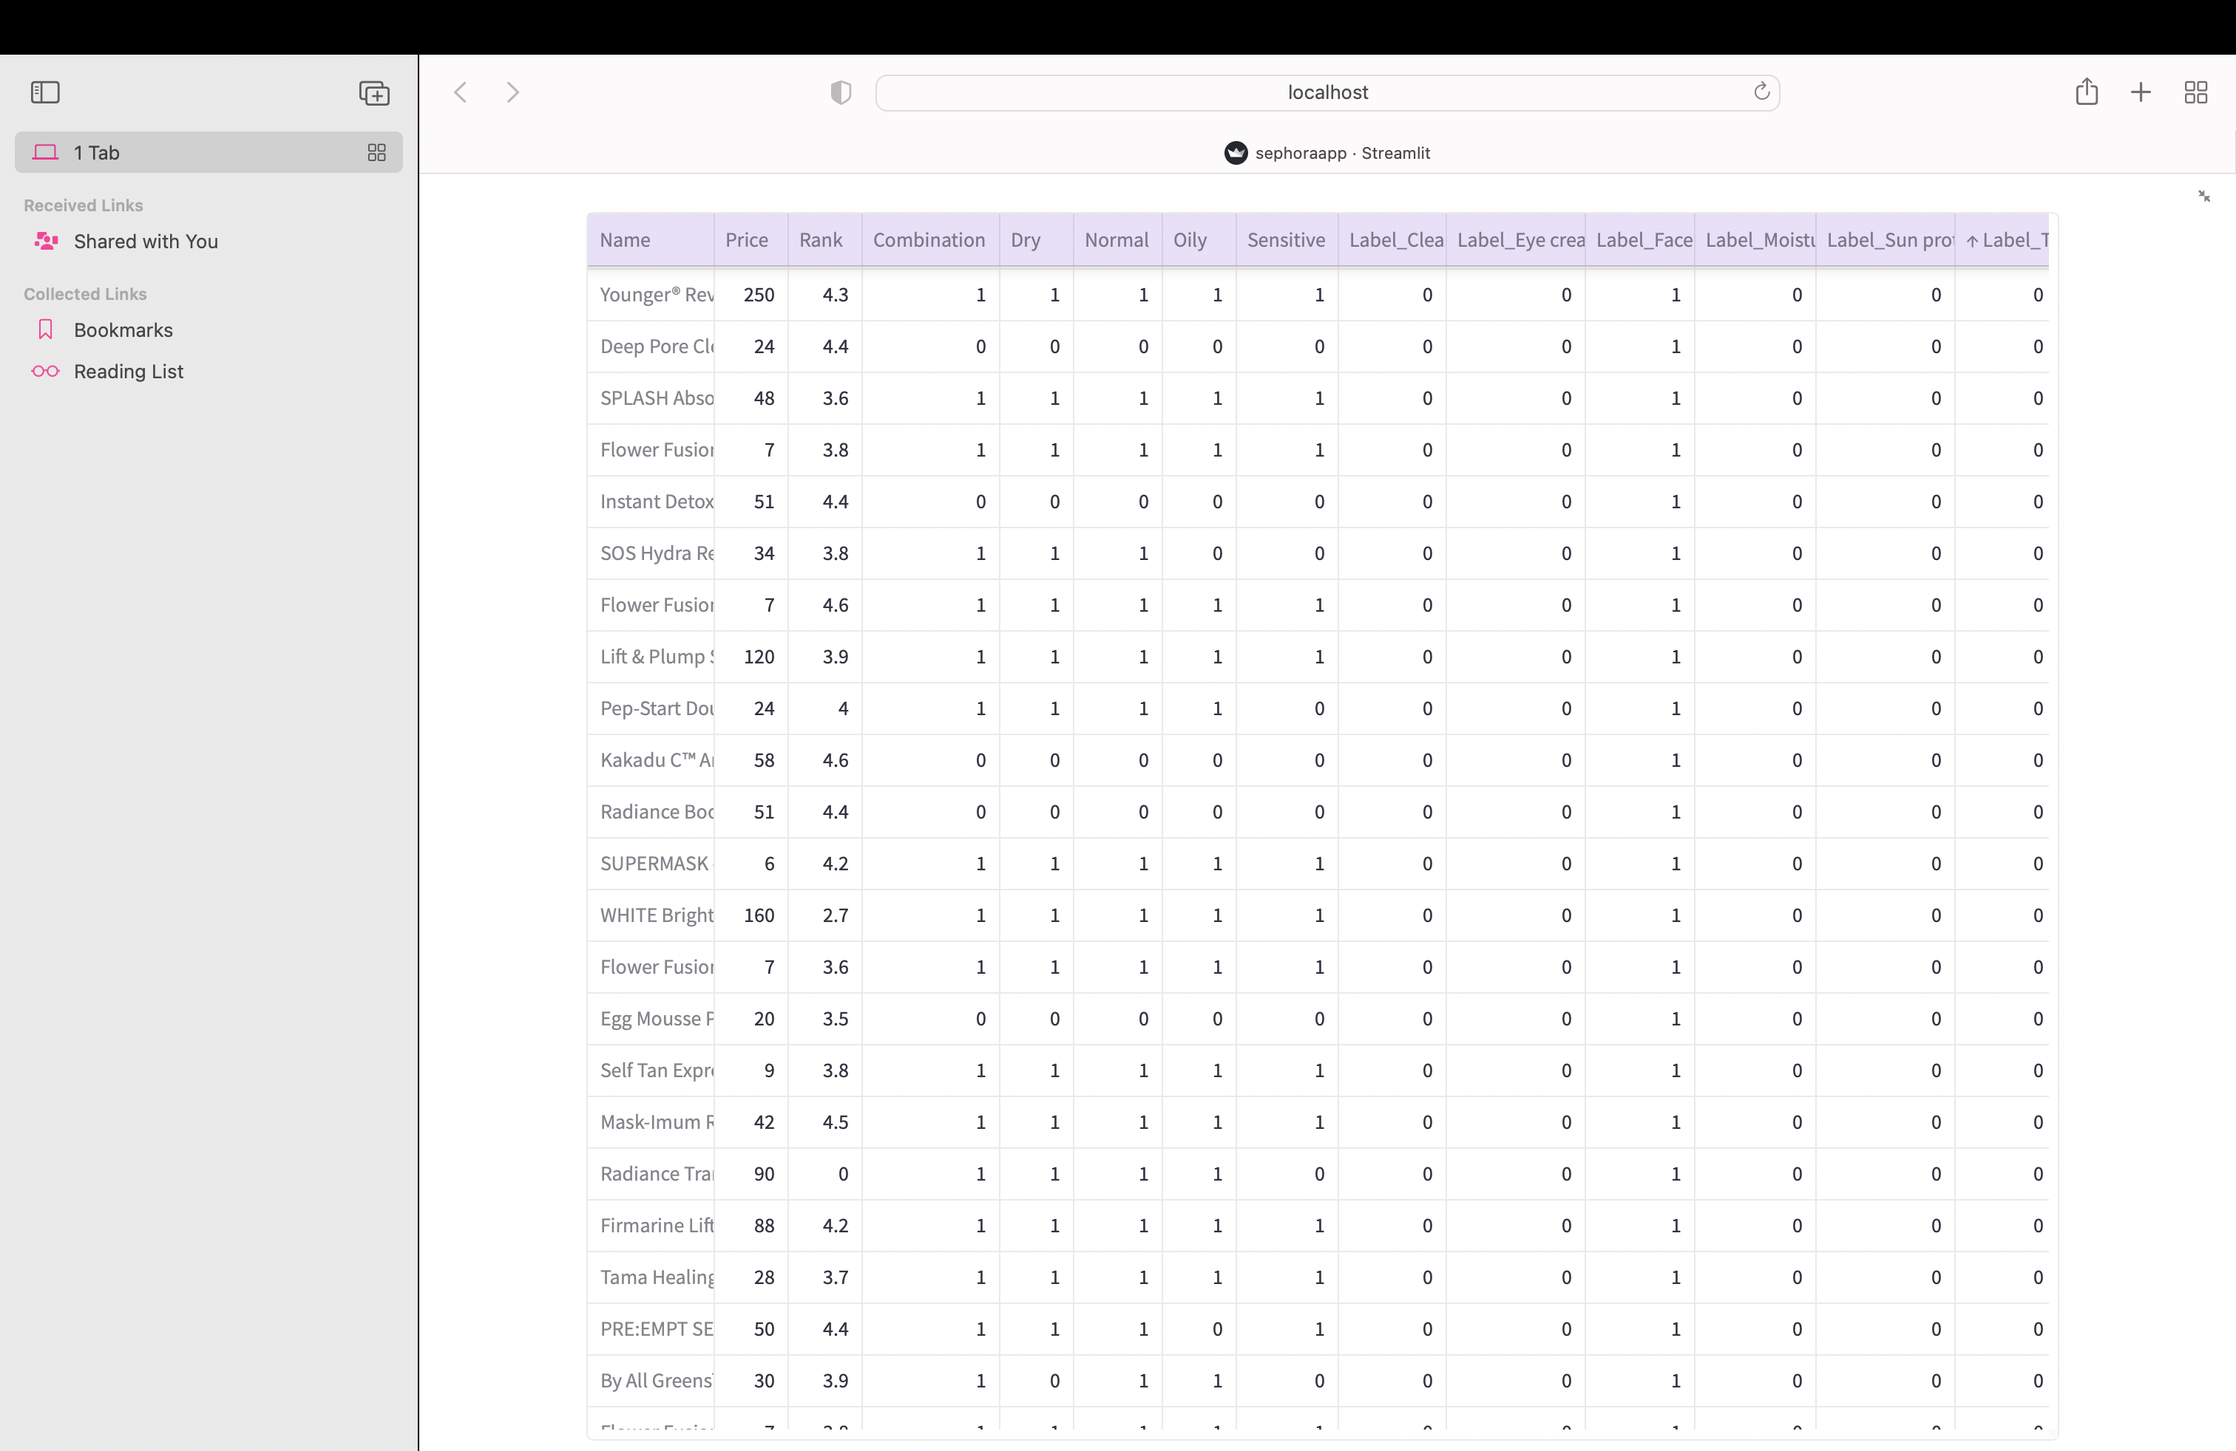

*Note.* Screenshot displaying the dataset prepared for K-Means clustering.

**Figure 7**

*K-Means Dataset*

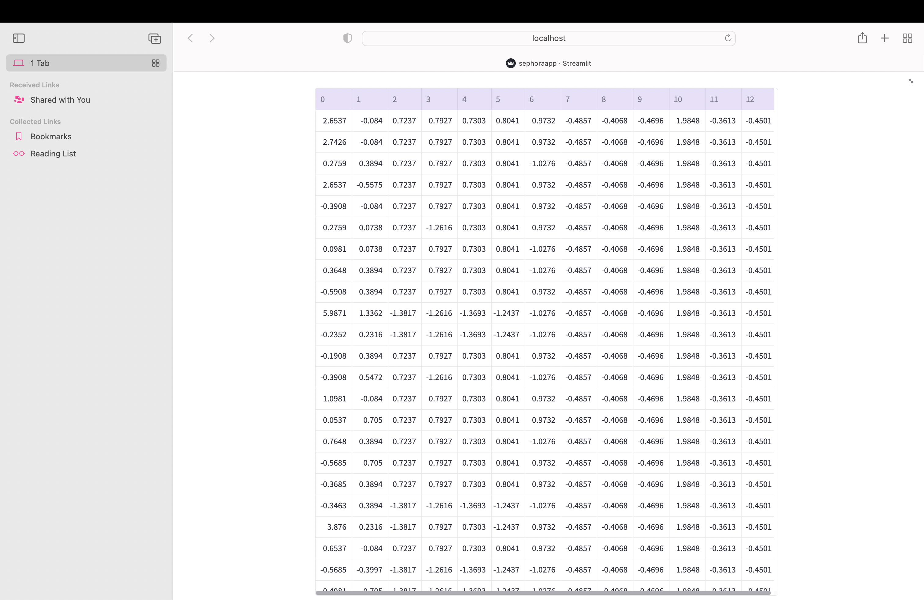

*Note.* Screenshot displaying the dataset prepared for K-Means clustering by setting to standard scale.

**Figure 8**

*K-Means Dataset with Clusters*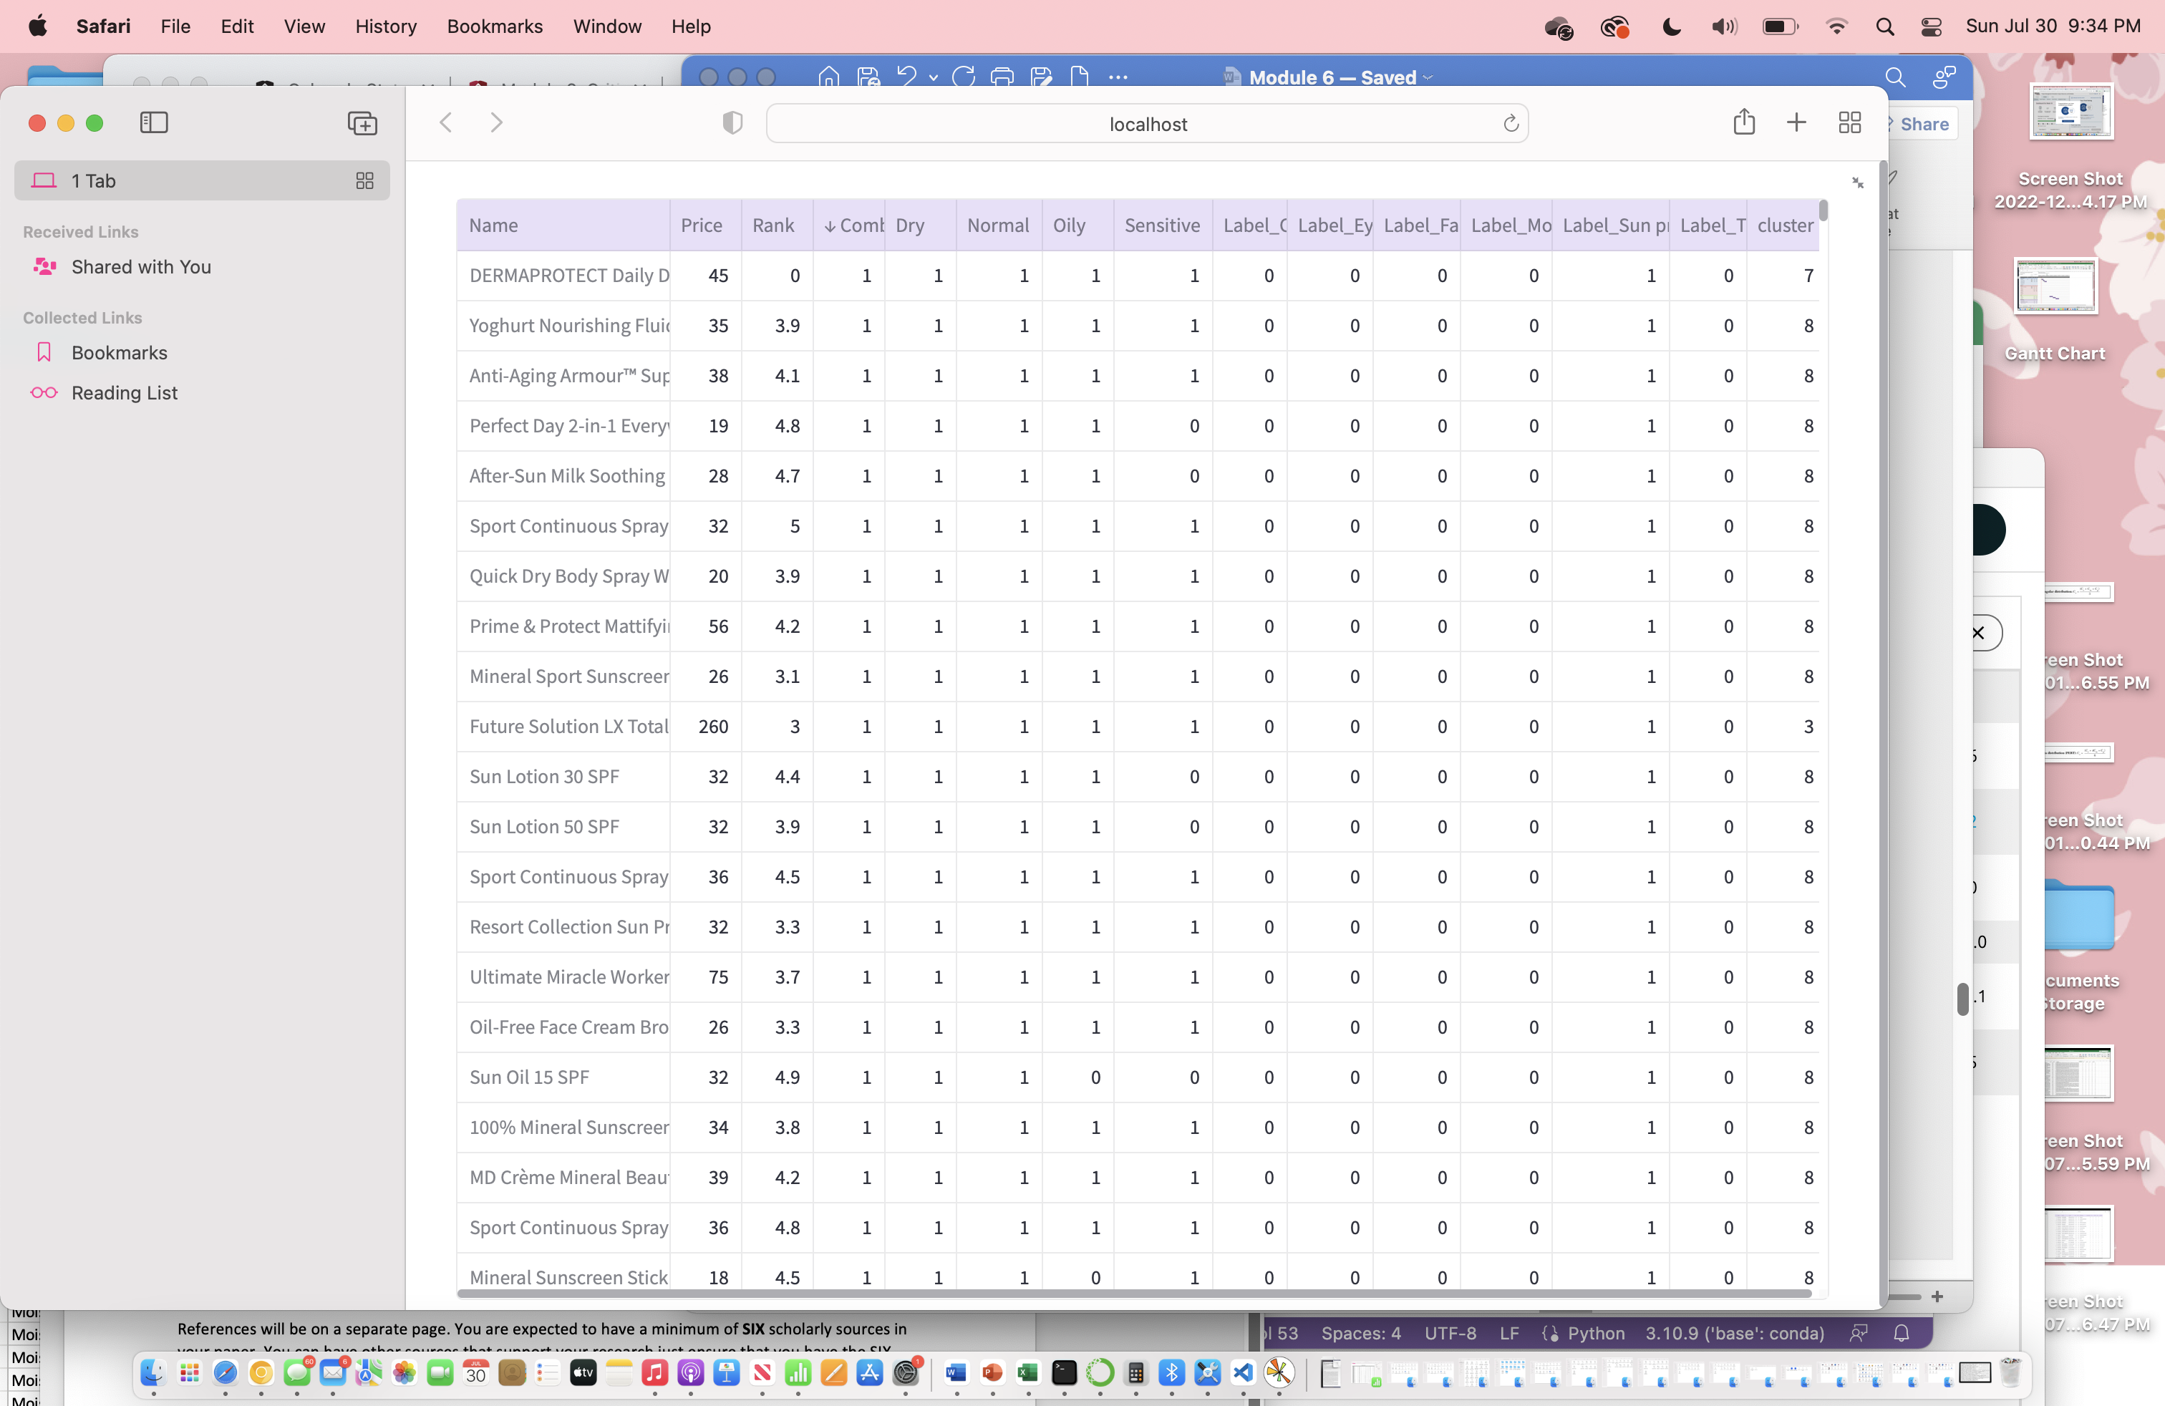

*Note.* Screenshot displaying the dataset with k-means clustering results.

**Figure 9**

*K-Means Silhouette Coefficient*

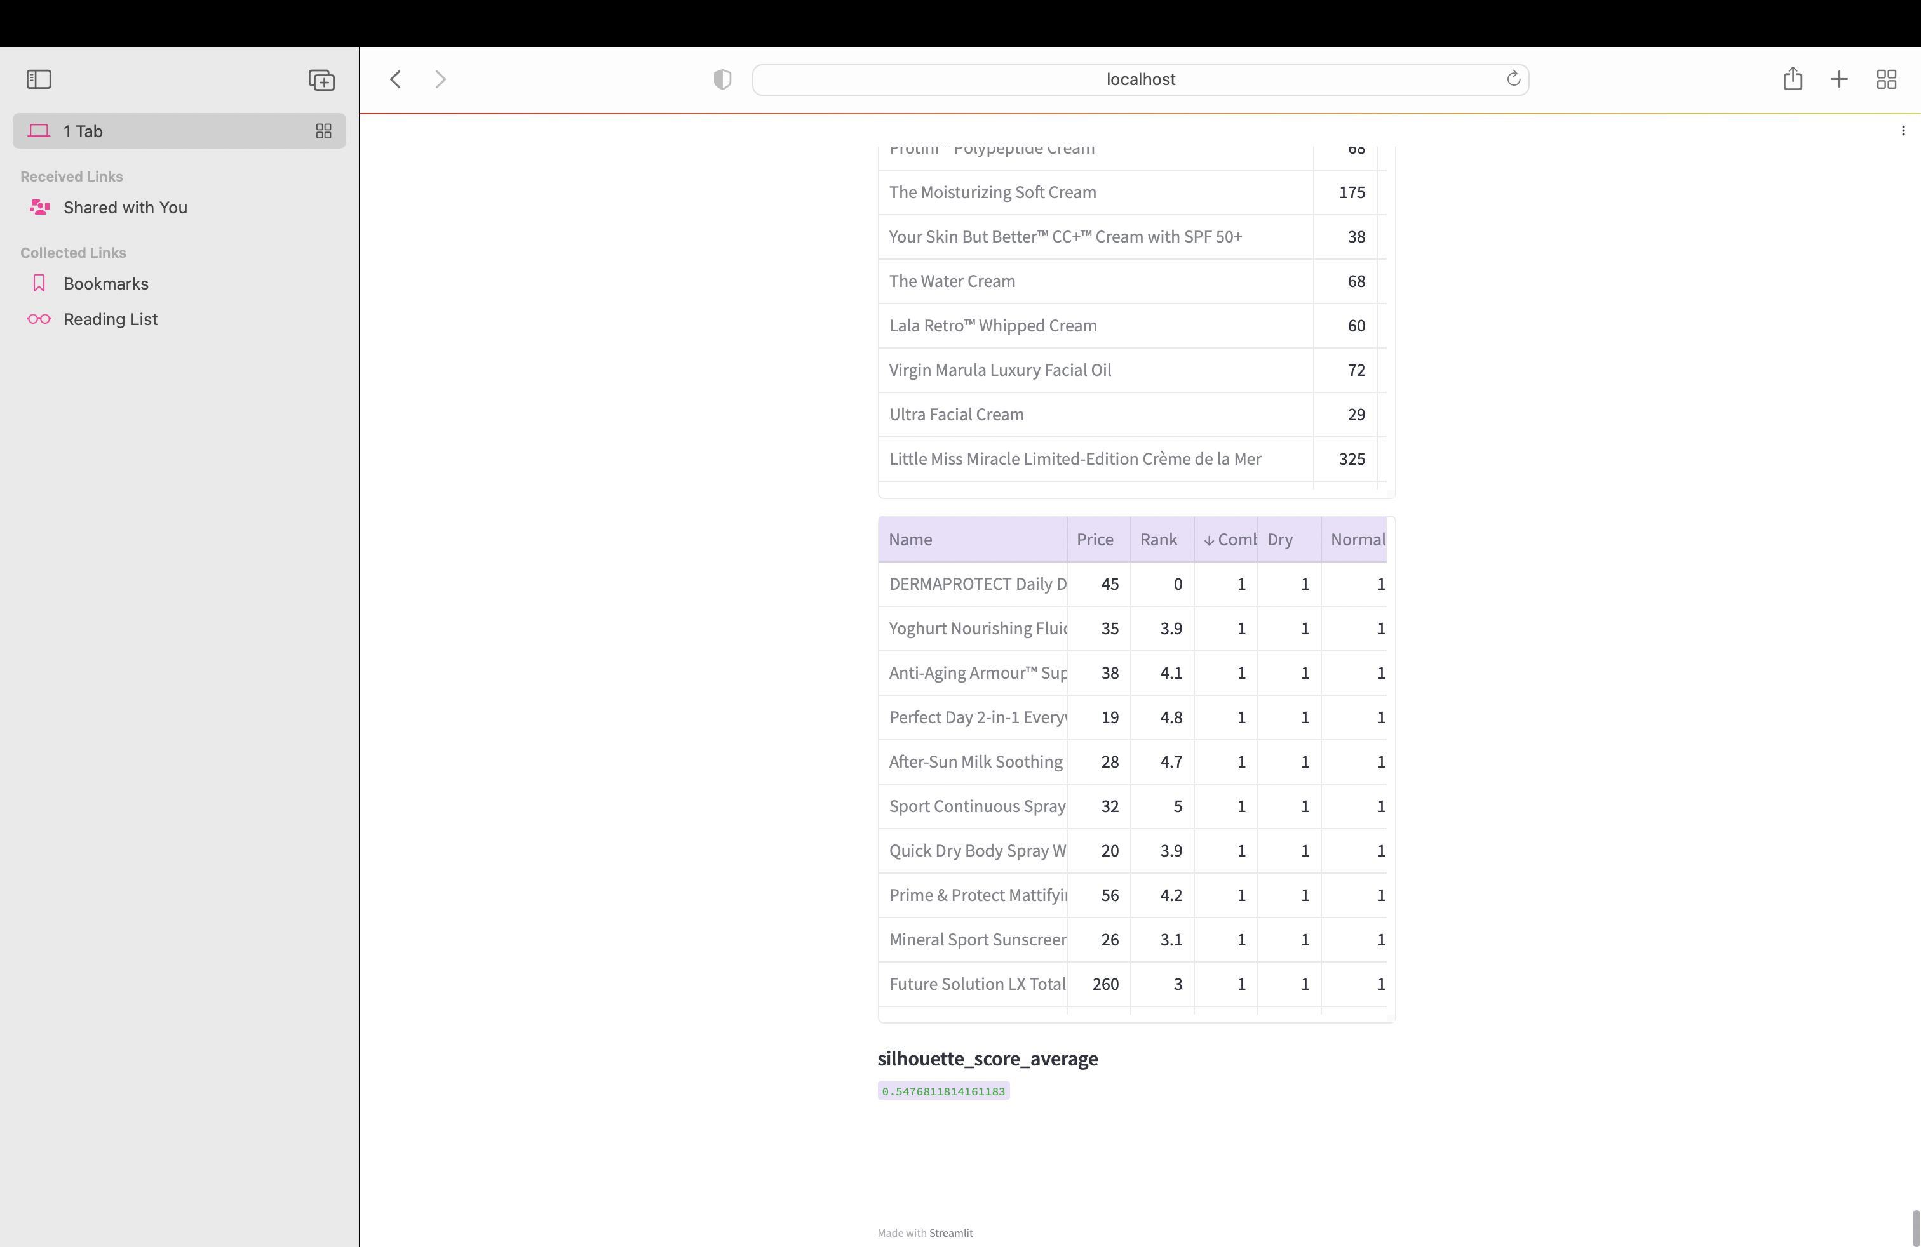

*Note.* Screenshot displaying the dataset with k-means clustering results.

**Figure 10**

*K-Means Scatterplot*

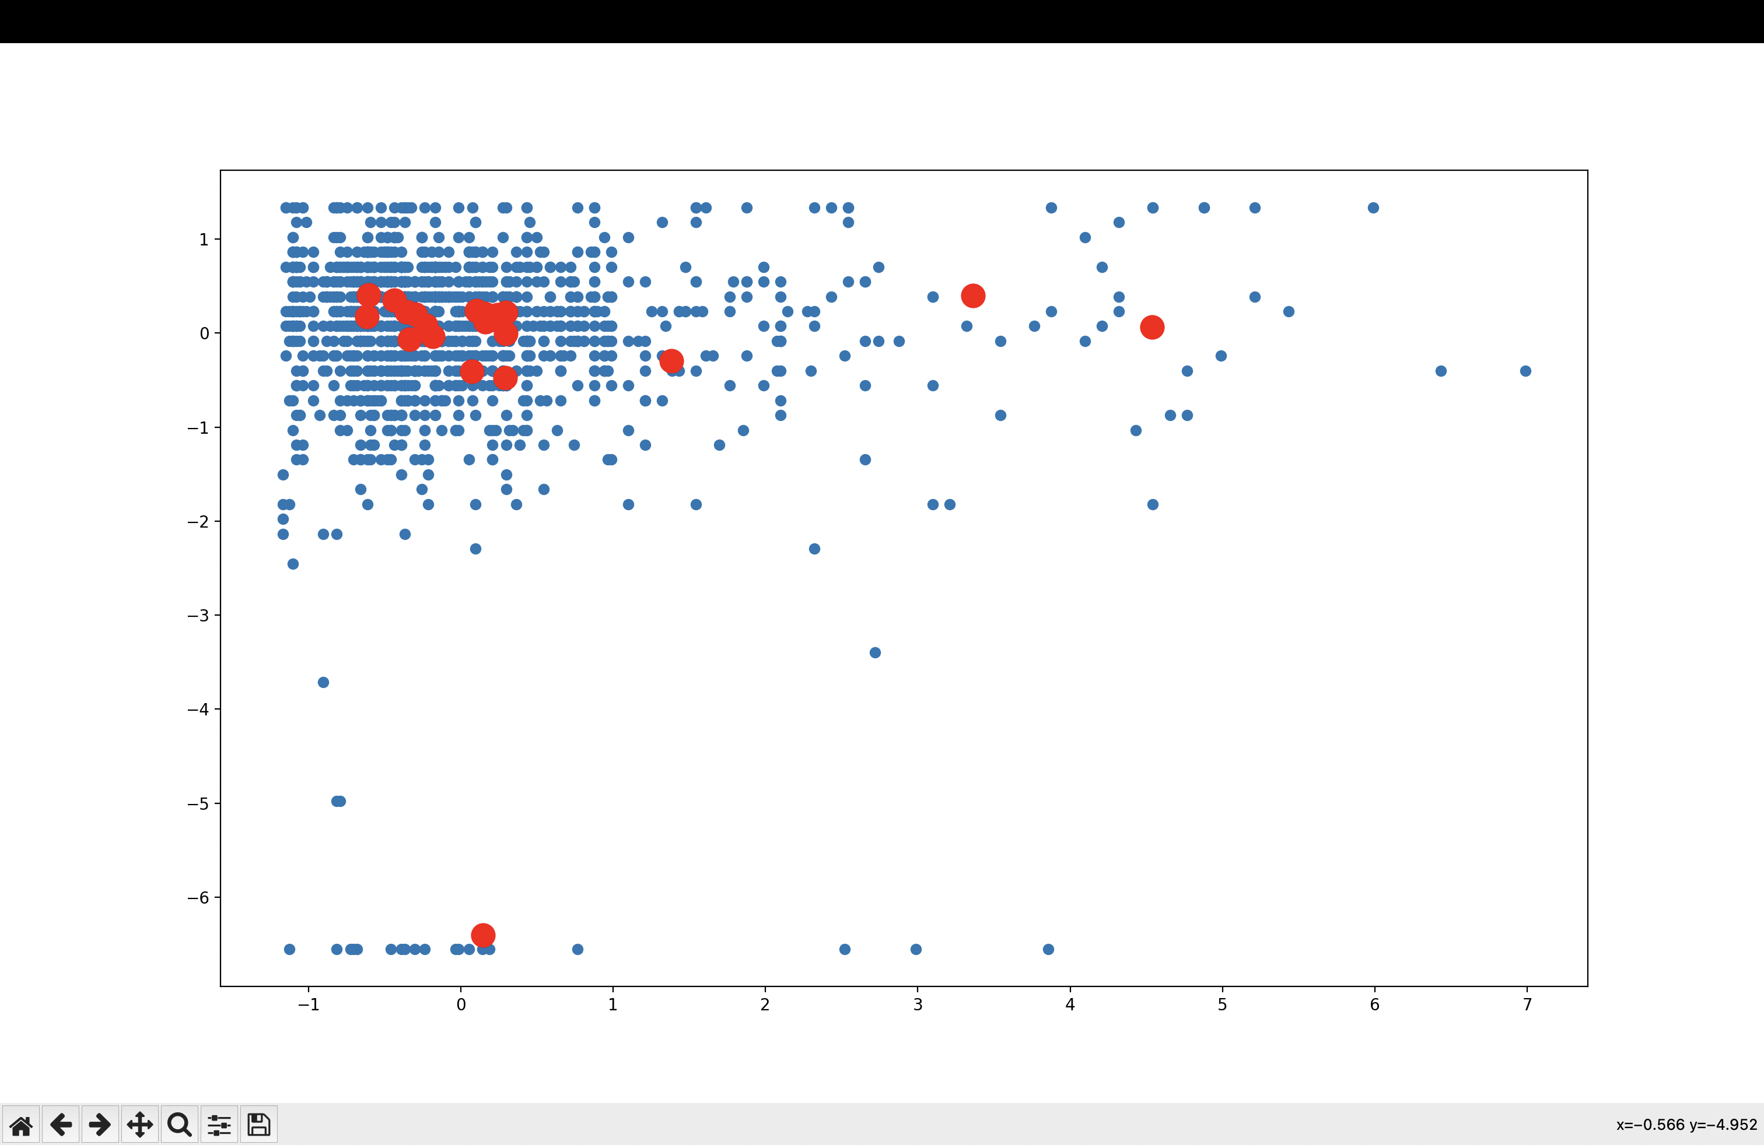

*Note.* Scatterplot of K-Means with cluster centroids.

**References**

Alfonso, V., Boar, C., Frost, J., Gambacorta, L., & Liu, J. (2021). E-commerce in the pandemic and beyond. *BIS bulletin*, *36*(9), 1-9. https://www.bis.org/publ/bisbull36_appendix.pdf

Awan, A. (2020). Cosmetics Datasets. Retrieved Jun 17, 2023, from <https://www.kaggle.com/datasets/kingabzpro/cosmetics-datasets>

Fisher, E. W., Khomenok, A., Rosser, H., Morgan, L., Mwansa, C., & Quispe, J. (2023). The World of Skincare and Beauty. <https://dspace.sewanee.edu/handle/11005/22030>

Fuentes, C., & Casella, G. (2009). Testing for the Existence of Clusters. *SORT (Barcelona)*, *33*(2), 115.

Krotov, V., Johnson, L., & Silva, L. (2020). Tutorial: Legality and ethics of web scraping. *Communications of the Association for Information Systems*. https://doi.org/10.17705/1CAIS.04724

Li, B. S., Cary, J. H., & Maibach, H. I. (2019). Science Behind Cosmetics and Skin Care. *Nanocosmetics: From Ideas to Products*, 3-15. https://link.springer.com/chapter/10.1007/978-3-030-16573-4_1

Maamoun, A. (2022). The cosmetics industry in the 2020s: a case study. *Global Journal of Business Pedagogy Volume*, *6*(1). 94-102. https://www.igbr.org/wp-content/uploads/articles/GJBP_Vol_6_No_1_2022%20pp%2094-102.pdf

Maulud, D., & Abdulazeez, A. M. (2020). A review on linear regression comprehensive in machine learning. *Journal of Applied Science and Technology Trends*, *1*(4), 140-147. <https://doi.org/10.38094/jastt1457>

Milusheva, V. (2020). Analysis of competitiveness of business organizations. *Trakia Journal of Sciences*, *18*(1), 401-409. http://www.uni-sz.bg/tsj/TJS%20-%20Suppl.1,%20Vol.18,%202020/67_V.Milu6eva.pdf

Mitić, V. (2019). Benefits of artificial intelligence and machine learning in marketing. In *Sinteza 2019-International scientific conference on information technology and data related research* (pp. 472-477). Singidunum University. <https://doi.org/10.15308/Sinteza-2019-472-477>

Nitesh, C., Himanshu, V., & Roshan, D. (2021). Cosmetics Market by Category (Skin and Sun Care Products, Hair Care Products, Deodorants & Fragrances, and Makeup & Color Cosmetics), Gender (Men, Women, and Unisex), and Distribution Channel (Hypermarkets/Supermarkets, Specialty Stores, Pharmacies, Online Sales Channels, and Others): Global Opportunity Analysis and Industry Forecast, 2021–2027. *Allied Market Research*. https://www.alliedmarketresearch.com/cosmetics-market

Park, Y. W., Hong, P., & Shin, G. C. (2022). Rising and thriving in the post COVID-19 era: a case study of COSMAX, a leader of the Korean cosmetic industry. *Asia Pacific Business Review*, 1-20. https://khu.elsevierpure.com/en/publications/rising-and-thriving-in-the-post-covid-19-era-a-case-study-of-cosm

Peña-García, N., Gil-Saura, I., Rodríguez-Orejuela, A., & Siqueira-Junior, J. R. (2020). Purchase intention and purchase behavior online: A cross-cultural approach. *Heliyon*, *6*(6). <https://www.cell.com/heliyon/pdf/S2405-8440(20)31128-2.pdf>

Shutaywi, M., & Kachouie, N. N. (2021). Silhouette analysis for performance evaluation in machine learning with applications to clustering. *Entropy*, *23*(6), 759

Sinaga, K. P., & Yang, M. S. (2020). Unsupervised K-means clustering algorithm. *IEEE access*, *8*, 80716-80727. https://ieeexplore.ieee.org/abstract/document/9072123

Yang, J., Xiu, P., Sun, L., Ying, L., & Muthu, B. (2022). Social media data analytics for business decision making system to competitive analysis. *Information Processing and Management*, 59(1). <https://doi.org/10.1016/j.ipm.2021.102751>

**Appendix**

|  |  |  |  |
| --- | --- | --- | --- |
| **Variable** | **Type** | **Description** | **Source** |
| Label | Str | Categorical variable that describes the category of product. | https://www.kaggle.com/datasets/kingabzpro/cosmetics-datasets |
| Brand | Str | Overall brand of product. | https://www.kaggle.com/datasets/kingabzpro/cosmetics-datasets |
| Name | Str | Specific product name for product. | https://www.kaggle.com/datasets/kingabzpro/cosmetics-datasets |
| Price | Int | Price in US dollars. | https://www.kaggle.com/datasets/kingabzpro/cosmetics-datasets |
| Rank | Int | Rank on Sephora website with 5 being highest rating. | https://www.kaggle.com/datasets/kingabzpro/cosmetics-datasets |
| Ingredients | Str | List of ingredients separated by commas. | https://www.kaggle.com/datasets/kingabzpro/cosmetics-datasets |
| Combination | Boolean | Boolean of whether product marketed to combination skin. | https://www.kaggle.com/datasets/kingabzpro/cosmetics-datasets |
| Dry | Boolean | Boolean of whether product marketed to dry skin. | https://www.kaggle.com/datasets/kingabzpro/cosmetics-datasets |
| Normal | Boolean | Boolean of whether product marketed to normal skin. | https://www.kaggle.com/datasets/kingabzpro/cosmetics-datasets |
| Oily | Boolean | Boolean of whether product marketed to oily skin. | https://www.kaggle.com/datasets/kingabzpro/cosmetics-datasets |
| Sensitive | Boolean | Boolean of whether product marketed to sensitive skin. | https://www.kaggle.com/datasets/kingabzpro/cosmetics-datasets |